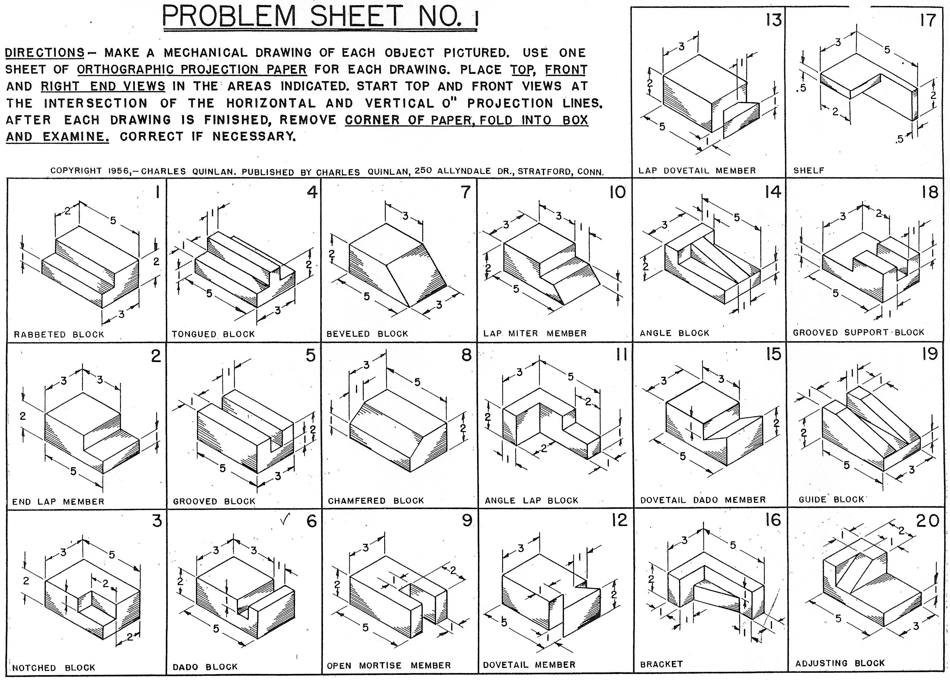

Draw each object in isometric.

You may use AutoCAD or ISO-sketch paper.