**Isometric Sketching Assignment**

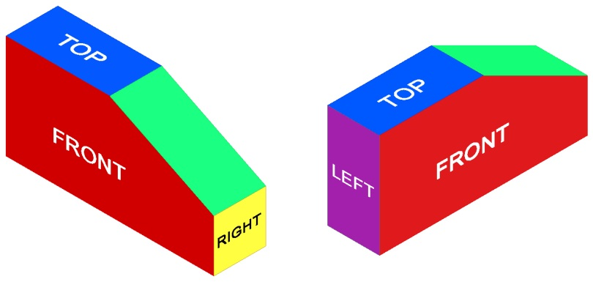

Make isometric sketches of the objects pictured below. Sketch the objects in the same orientation that they are pictured in.

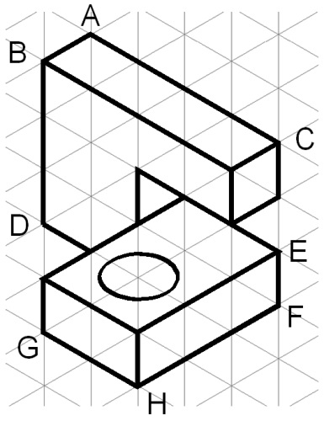 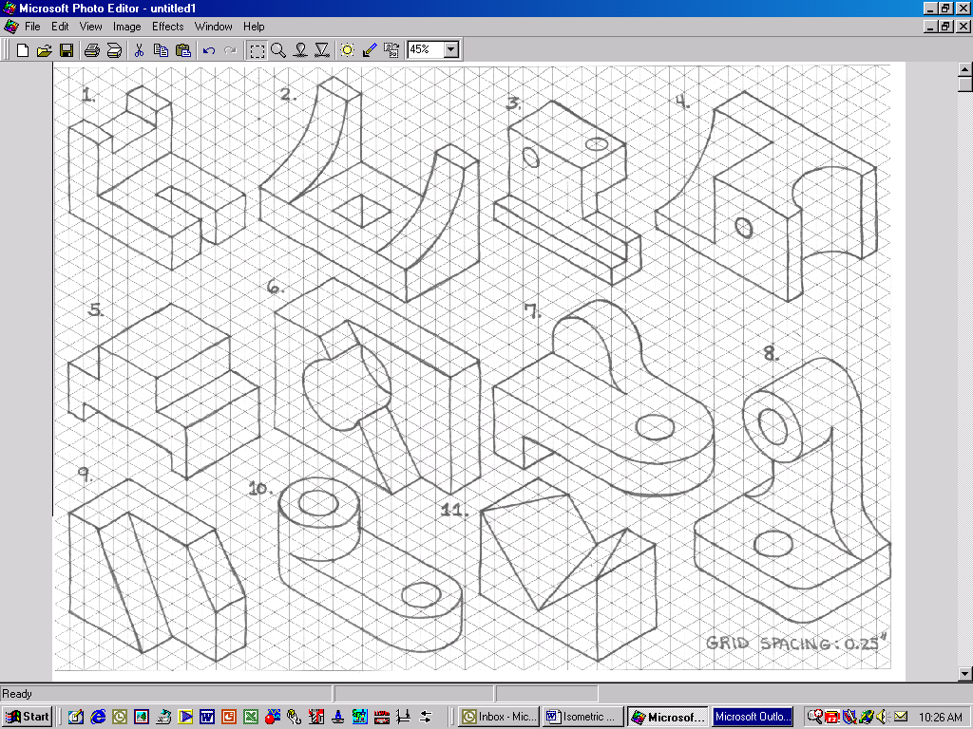 

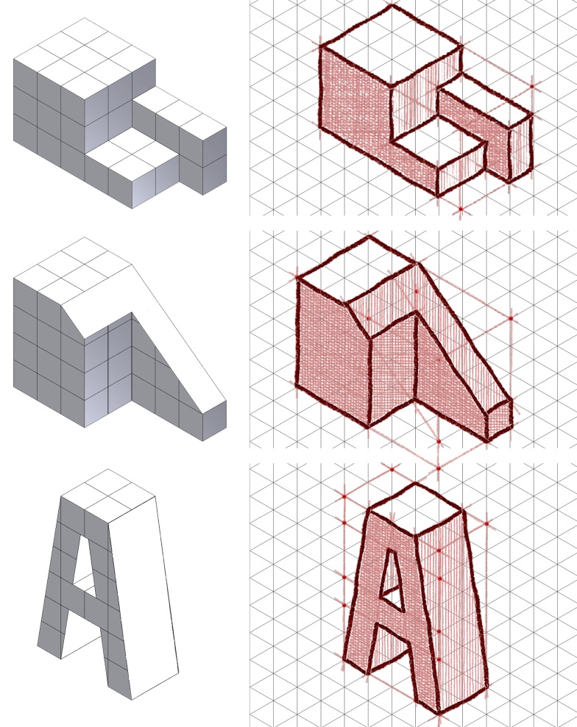 

**Answer these questions:**

What is the difference between a two-dimensional sketch and an isometric sketch?

If you were not given isometric graph paper, what technique could you use to approximate the proper isometric angles in order to complete an isometric sketch?

Name:___________________________________

Period:_________