Lego Minifig Project
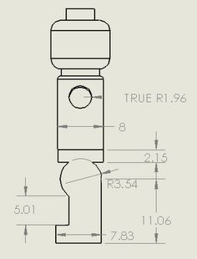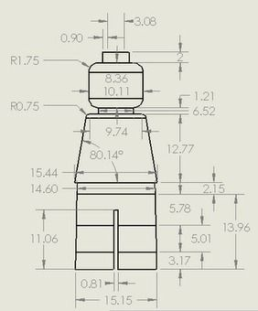

Your final project will include each of the following:
- Design Journal
- Sketch
- Manual drafting
- Orthographic
- Dimensions
- Oblique
- Isometric
- Perspective
- Full section
- Final rendering – full color

