Name: _______________________________________________________ Period: __________

Perspective Packet

The following are your assignments for perspective. You are only to complete ONE page at a time. When you finish each page show it to the teacher to sign off and check your perspective.

1 Point Perspective Assignments |  | Teacher Signature | Points
1. | One-Point Perspective Pictures | ________________ | _____/10
1. | Boxes Above Below and on the Horizon Line | ________________ | _____/10
1. | Letters in Perspective | ________________ | _____/10
1. | Shapes in Perspective | ________________ | _____/10
1. | Stars in Perspective | ________________ | _____/10
1. | Real Word Objects | ________________ | _____/10
1. | Draw Part of a Room | ________________ | _____/20
1. | Create a City | ________________ | _____/50
 |  | Total | _____/130

2 Point Perspective Assignments |  | Teacher Signature | Points
1. | Two-Point Perspective Pictures | ________________ | _____/10
1. | Boxes Above Below and on the Horizon Line | ________________ | _____/10
1. | Letters in Perspective | ________________ | _____/10
1. | Everyday Objects | ________________ | _____/10
1. | Buildings, Structures and Truck | ________________ | _____/10
1. | Final Project Fantasy City | ________________ | _____/150
 |  | Total | _____/200

Linear Perspective

Linear Perspective is a technique for representing 3-dimensional space on a 2-dimensional (paper) surface. This method was invented during the Renaissance when artists were trying to draw as realistically as possible. It is a mathematical system to show depth realistically. Linear perspective is based on the way the human eye sees the world. Things that are closer to us appear larger and things that are farther away appear smaller. To create this illusion the artist creates a vanishing point on the horizon line. Objects are drawn using orthogonal lines, which lead to the vanishing point(s).

Things that are seen face on, which means you are looking at the front of them directly, are drawn in one-point perspective with a single vanishing point.
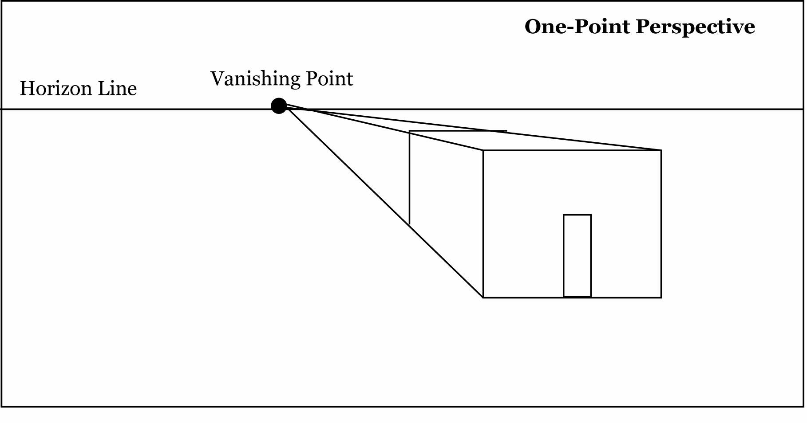

Things that are seen at an angle, which means you aren’t looking at the front of something but at the angle or corner, are drawn in two-point perspective using two vanishing points.
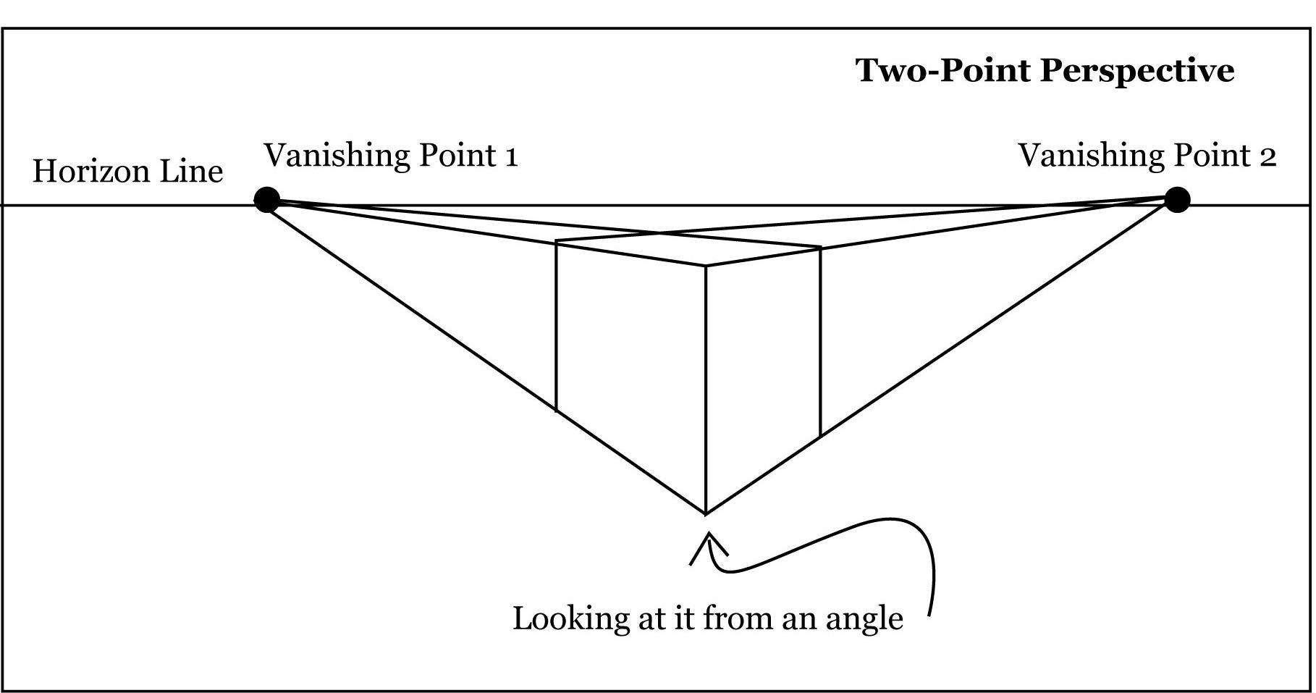
Linear Perspective
Vocabulary Words

Perspective: Perspective is a way of showing where the observer is. The objects themselves don’t have perspective, you the observer, do.

One-Point Perspective: One-point perspective occurs when rectangular forms are placed so that their sides are either parallel to the picture plane or perpendicular to it. There is one central vanishing point in one-point perspective.

Two-Point Perspective: Two-point perspective is necessary when rectangular objects are positioned so that their faces are at an angle to the artist’s line of sight. There are two vanishing points for an object in two-point perspective. If there are two cubes at different angles to the viewer each cube will have it’s own vanishing points, but only one horizon line.

Horizon Line: The horizon line is the same as the real horizon (where the earth meets the sky). The horizon line is also considered to be at the artist’s eye level. If the horizon line cannot be seen because of obstructions it can be located by drawing a line at the artist’s eye level.

Vanishing Point(s): In perspective, the lines of an object extend to and meet at the vanishing point, which is on the horizon line.

Orthogonal Lines: The term used to describe parallel lines which appear to converge in the system of linear (one-point) perspective.

Horizontal Lines: Straight lines parallel to the horizon.

Vertical Lines: Lines that are drawn at right angles to the horizon, running straight up and down.

Diagonal Line: A straight line from a corner to the opposite (diagonal) corner of a cube, rectangle, parallelogram, etc.

One-Point Perspective Pictures

With a pencil and an eraser draw the Horizon Line, Vanishing Point(s), Orthogonal Lines and Vertical Lines in these one-point perspective pictures. Label all.
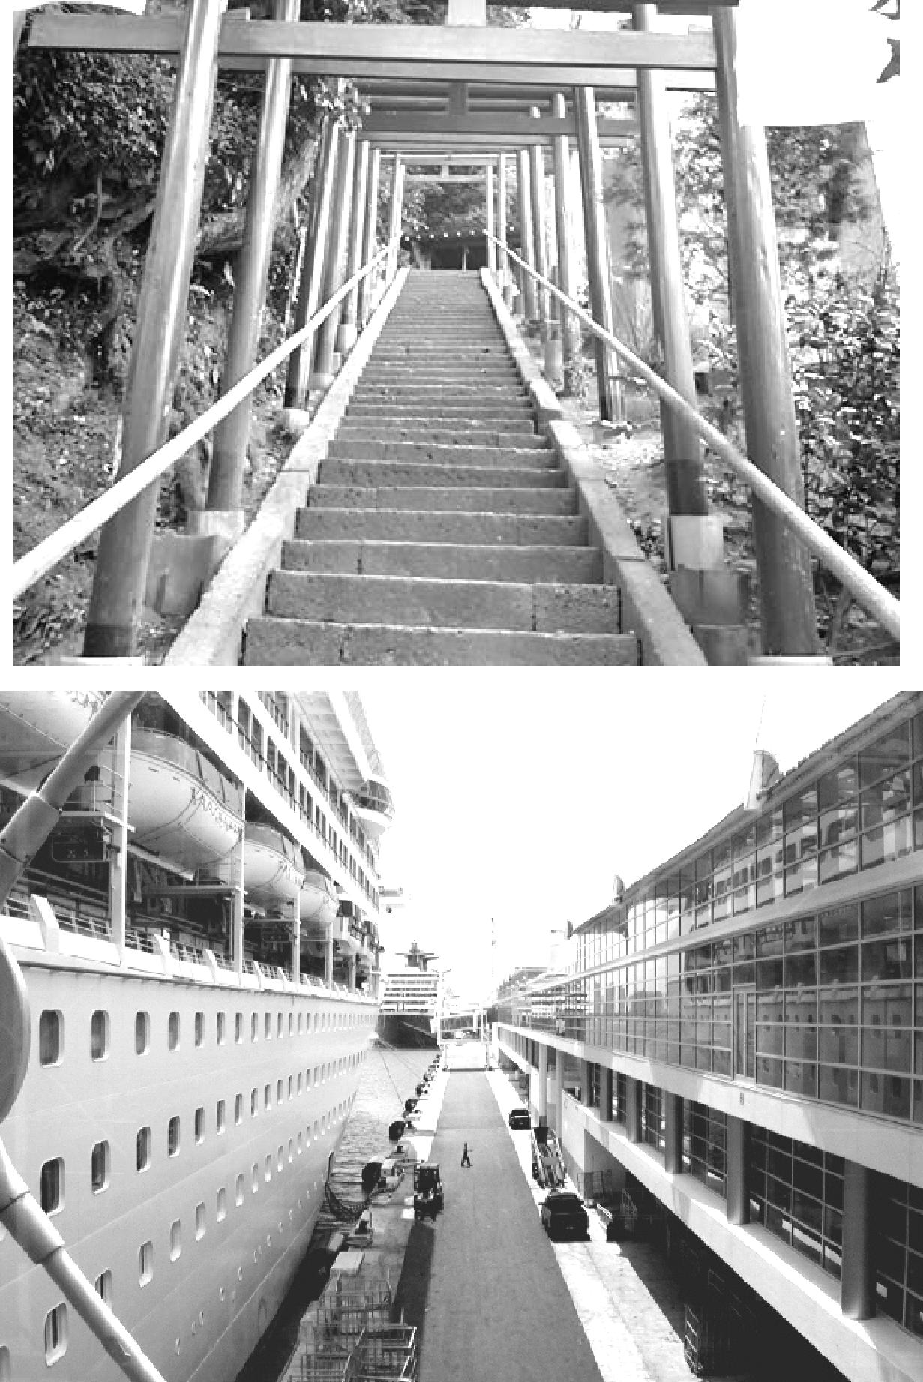
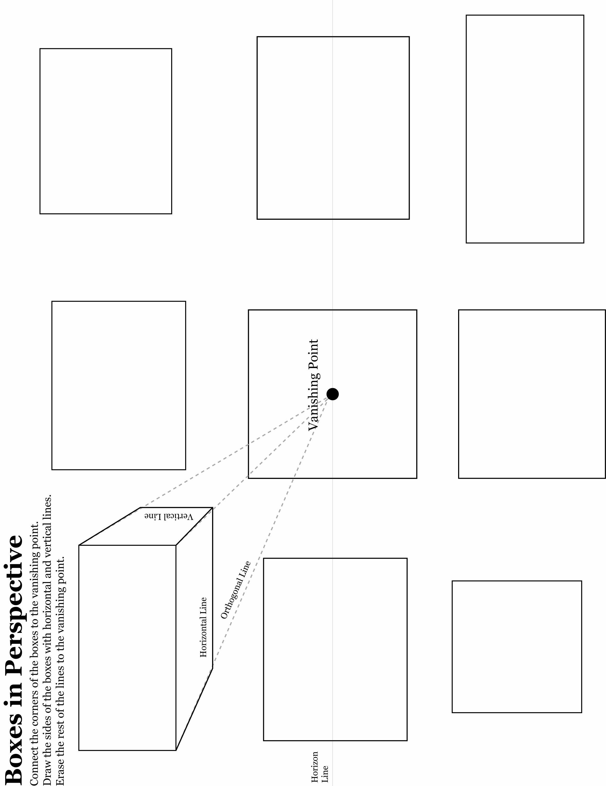
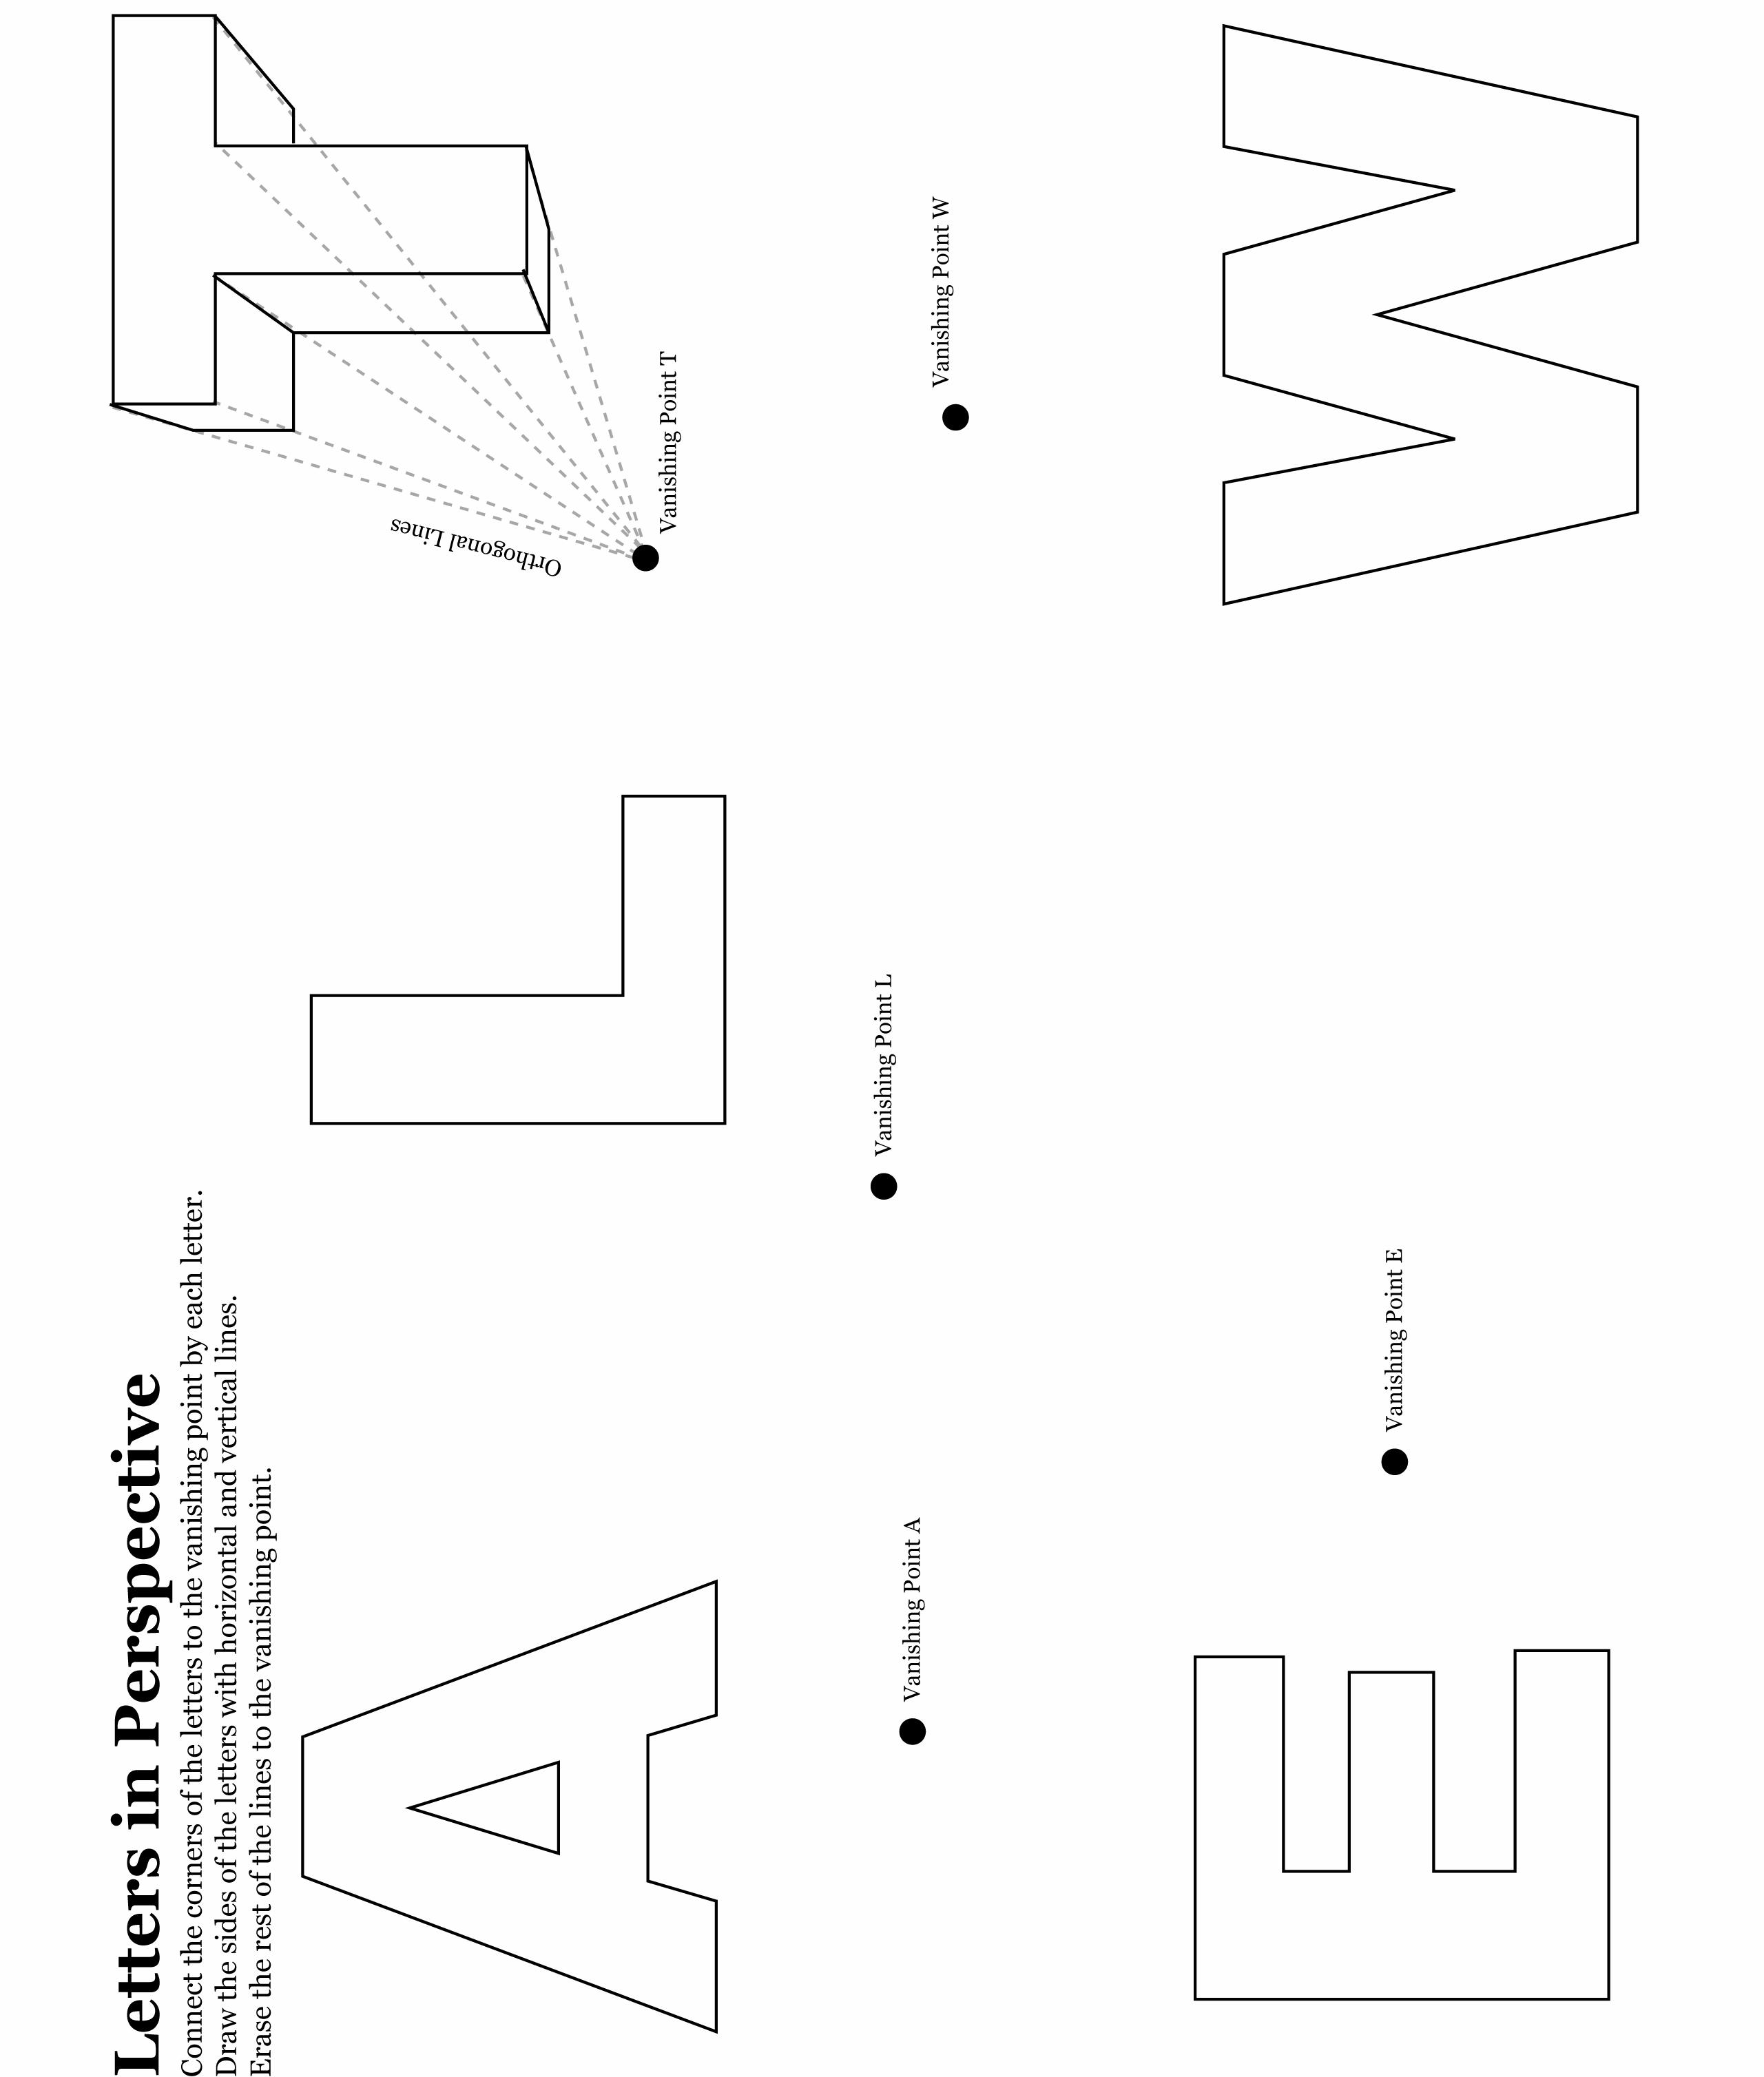
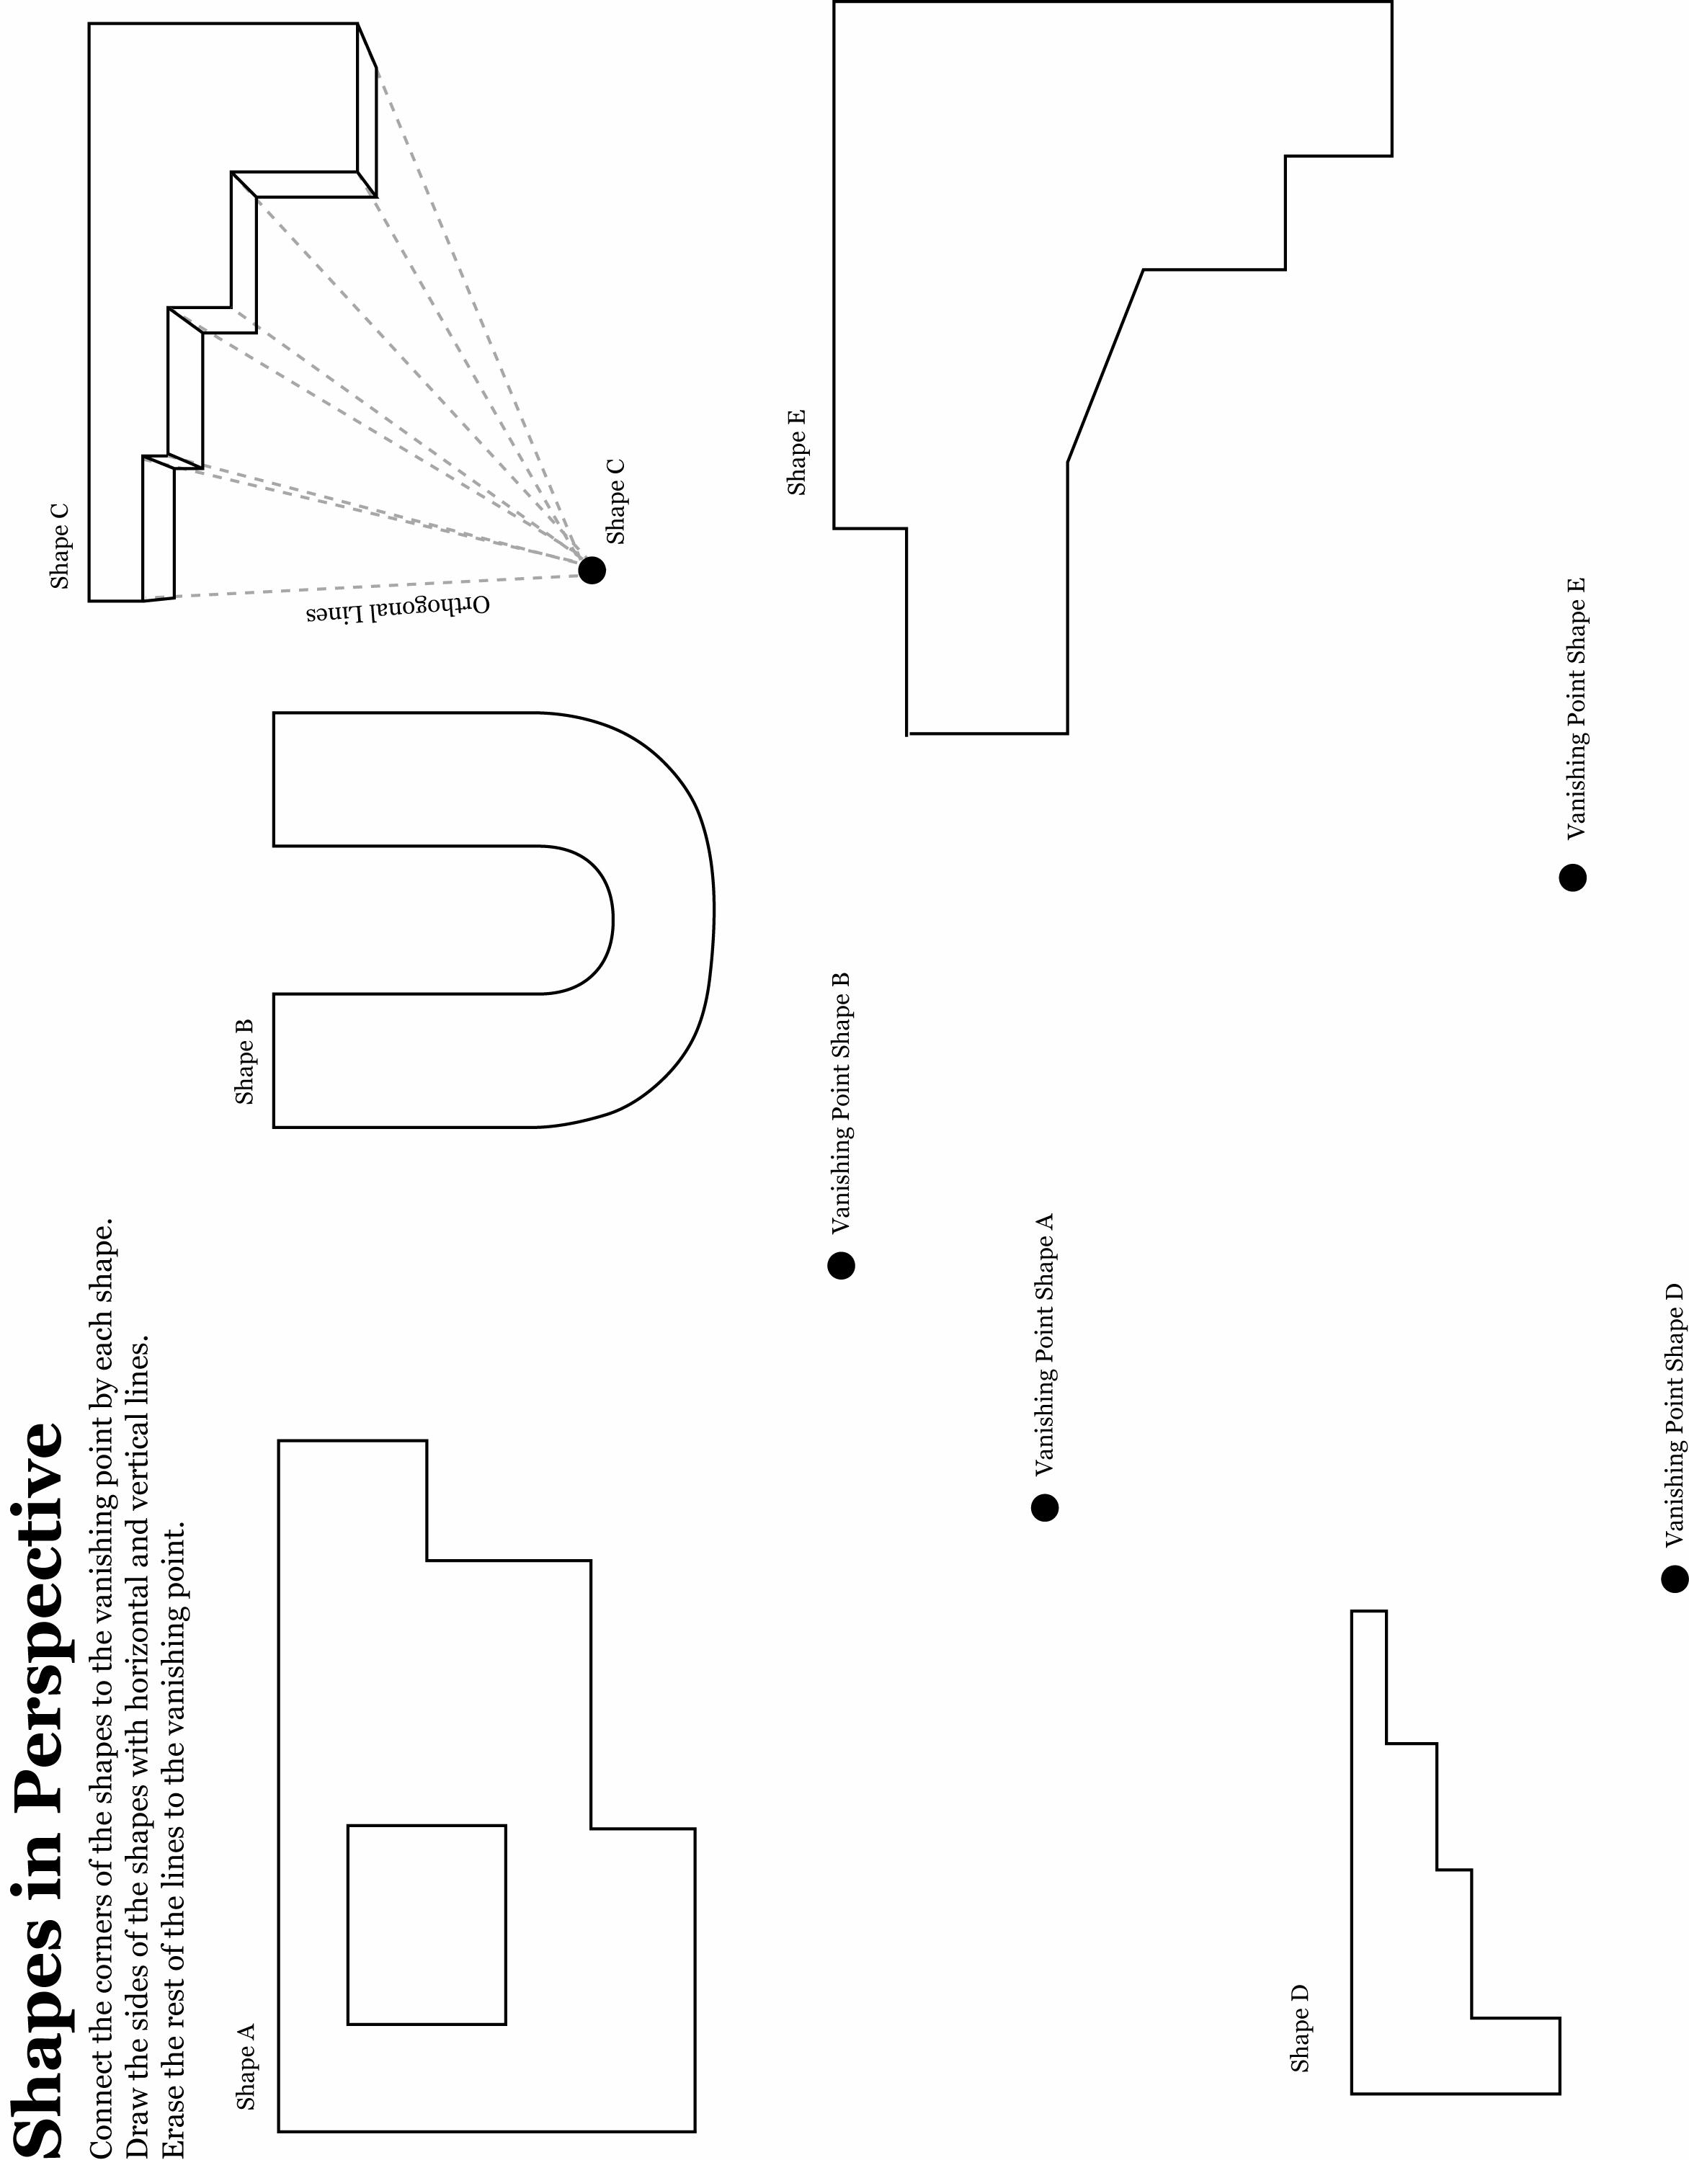
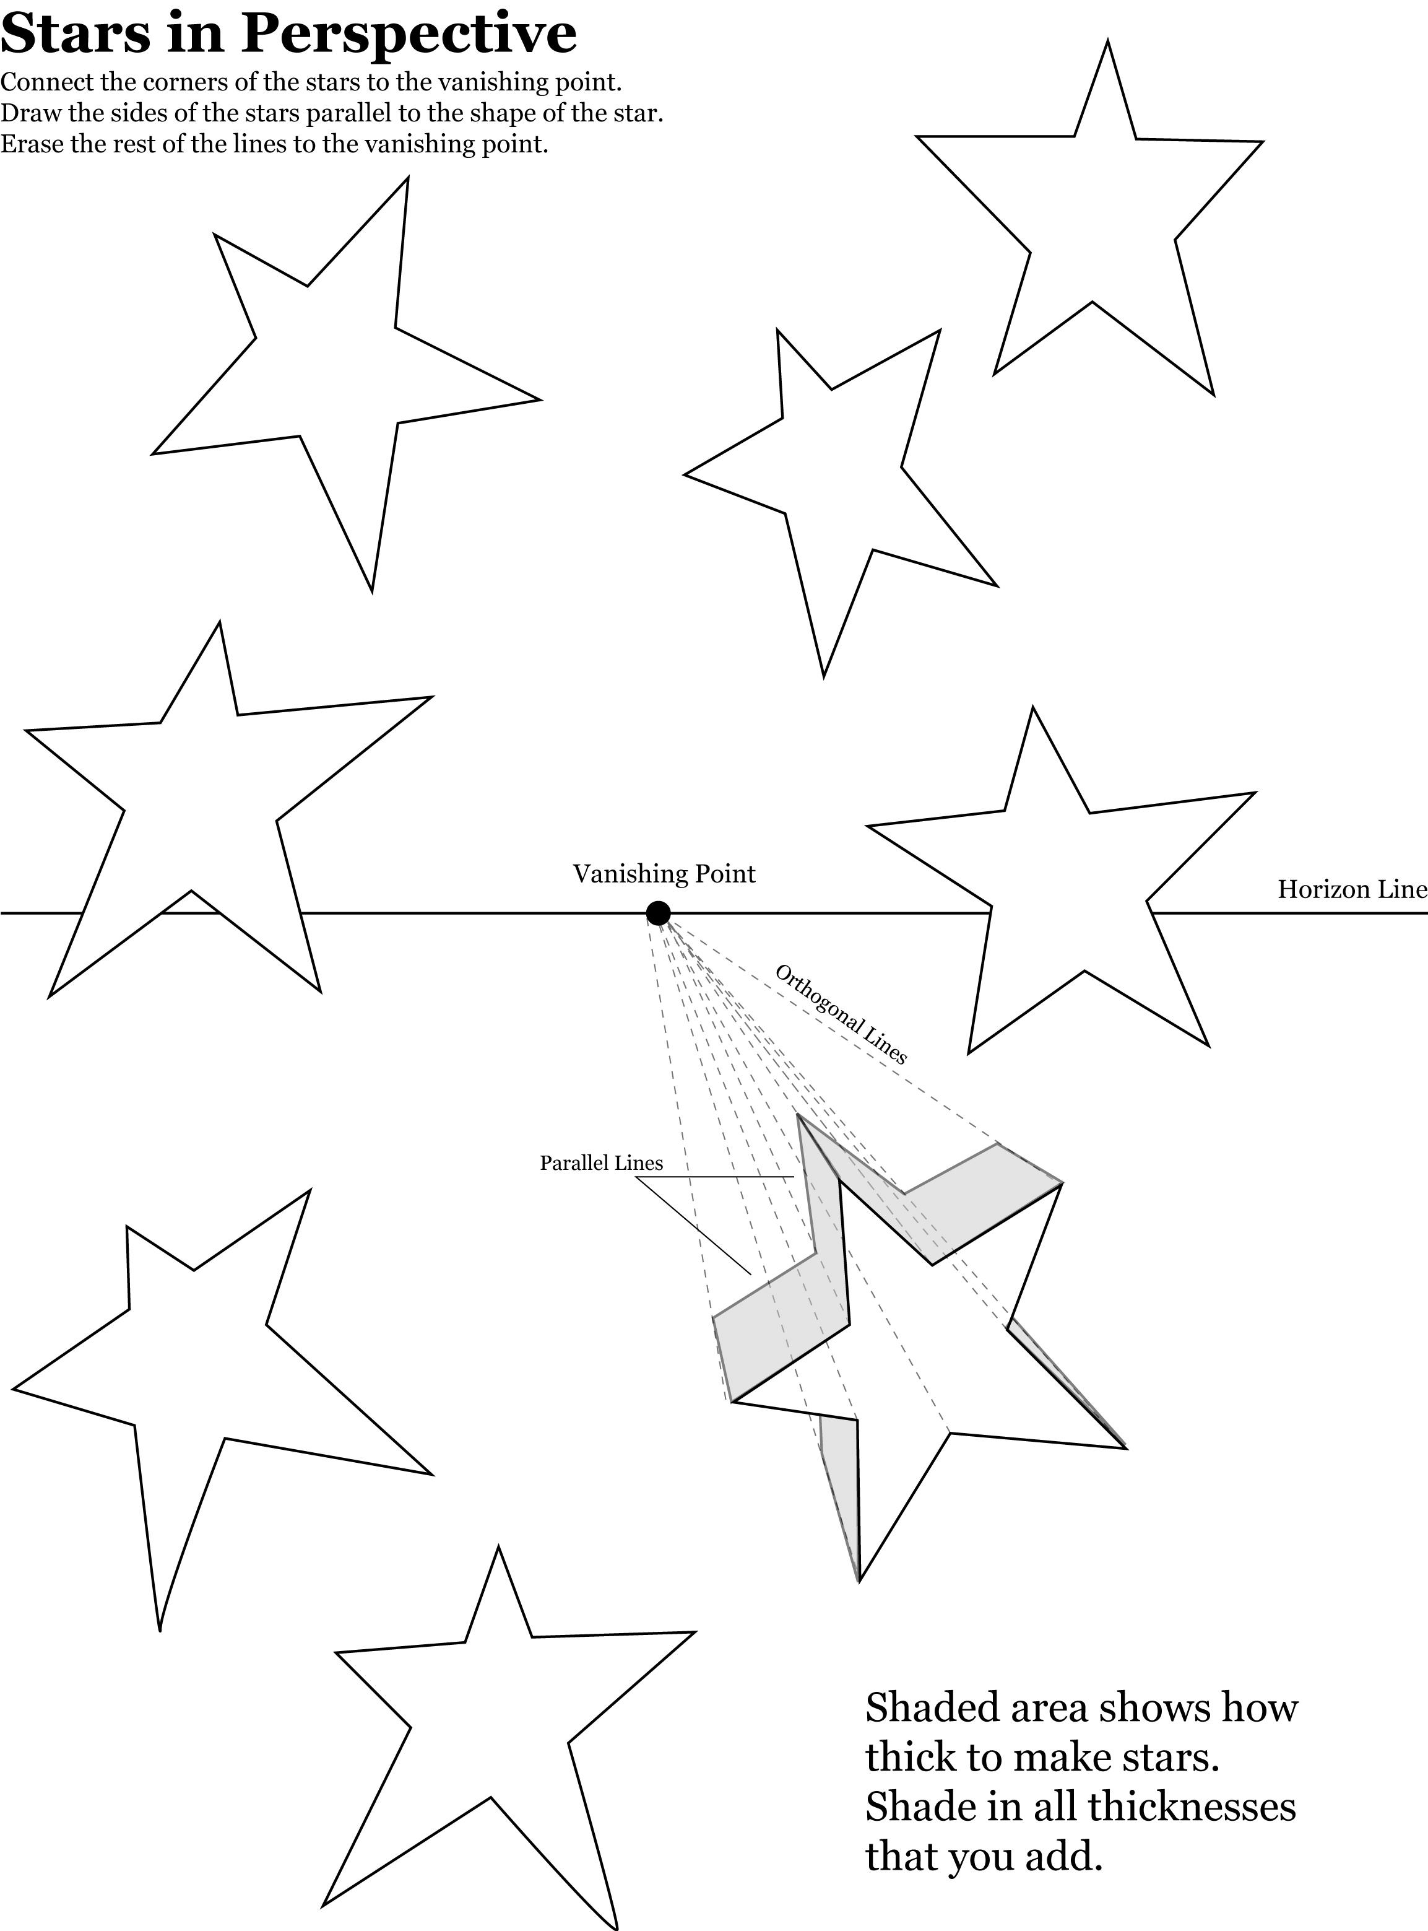
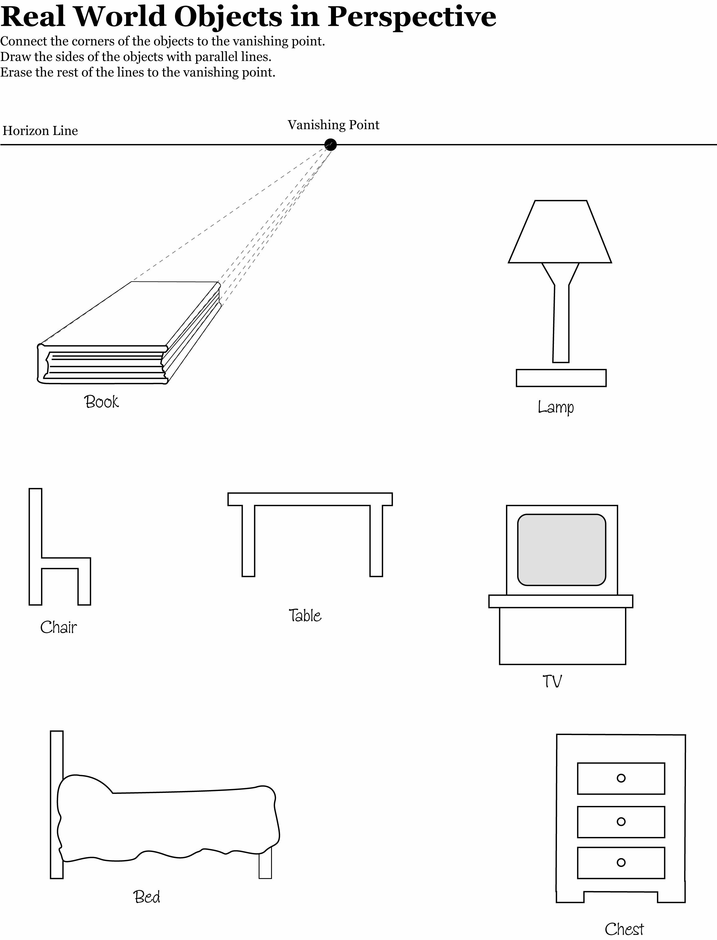
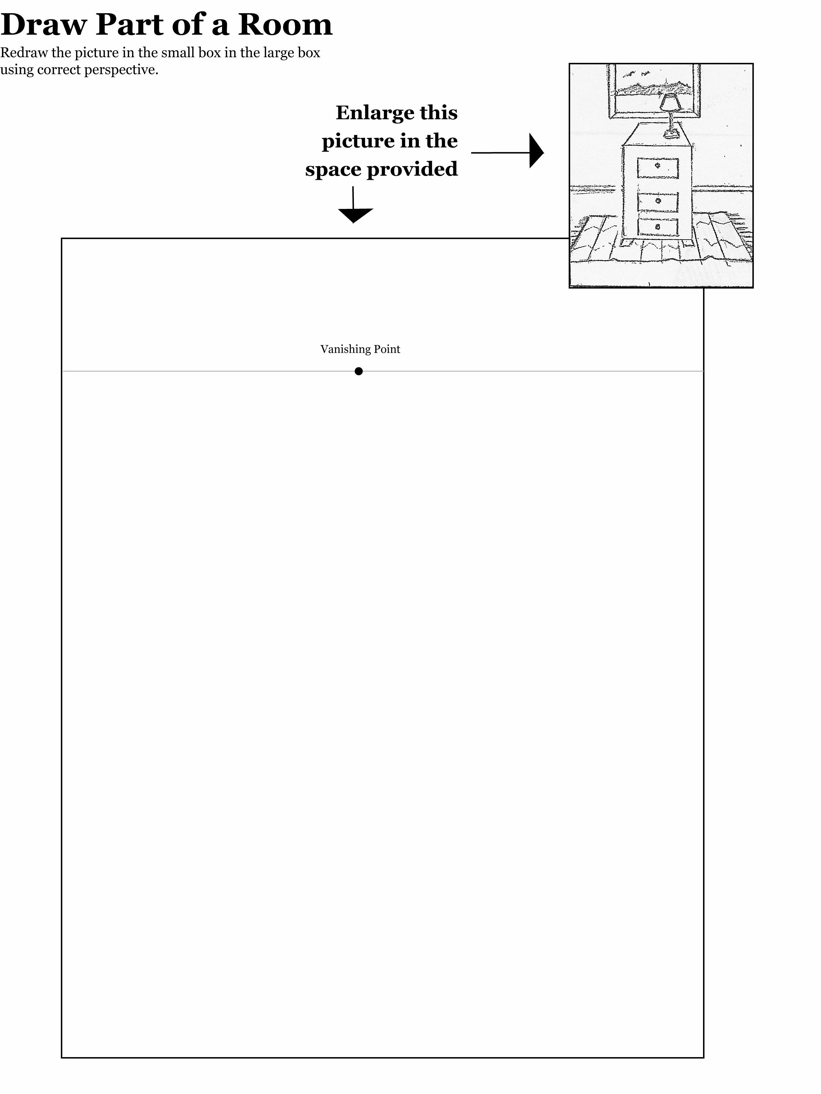
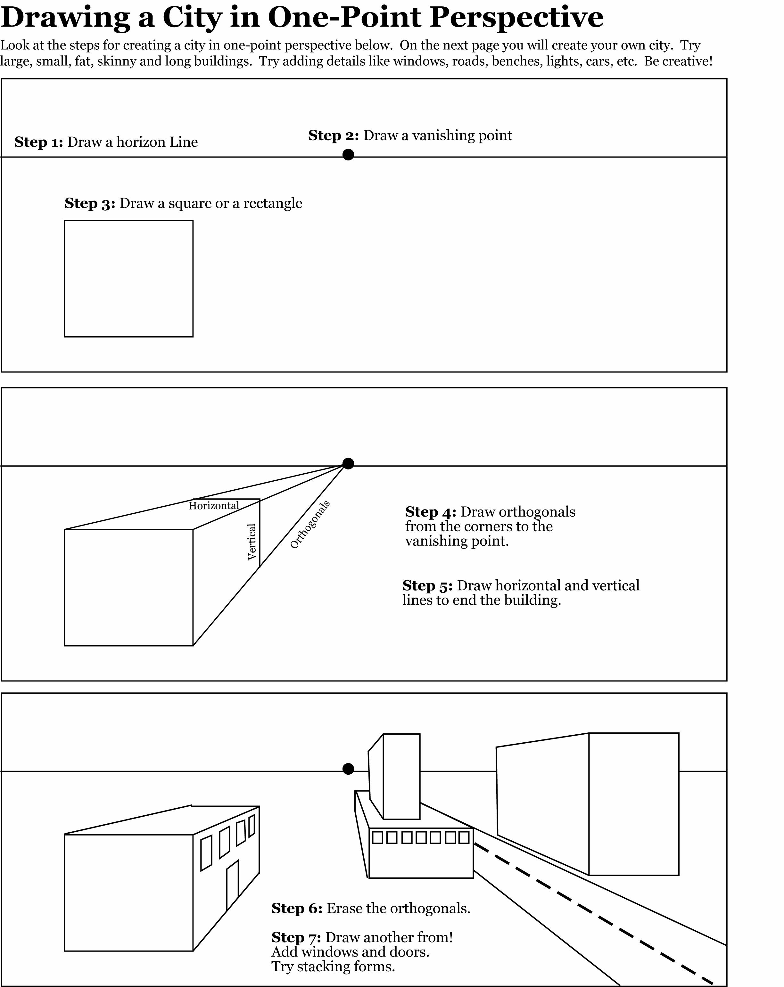
Draw Your City Here

Remember the steps:

Step 1: Draw a horizon line. Step 2: Draw a vanishing point. Step 3: Draw a square or rectangle. Step 4: Draw orthogonals from the corners to the vanishing point. Step 5: Draw horizontal and vertical lines to end the building. Step 6: Erase the orthogonals you don't need for the building. Step 7: Draw more buildings. Add windows, roads, doors, benches, lights, trees, cars, etc. Be Creative!
Two-Point Perspective Pictures

With a pencil and an eraser draw the Horizon Line, Vanishing Points, Orthogonal Lines and Vertical Lines in these two-point perspective pictures. Label all.
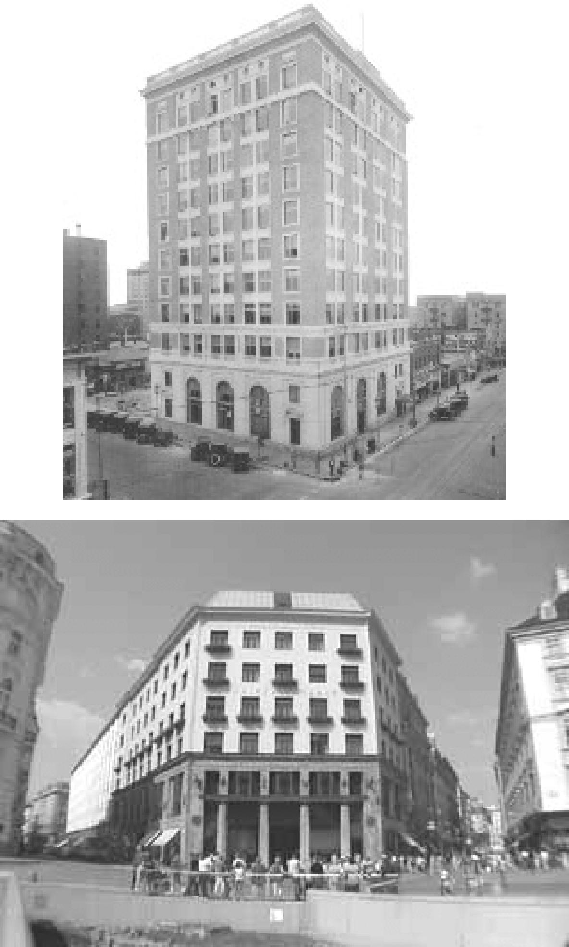
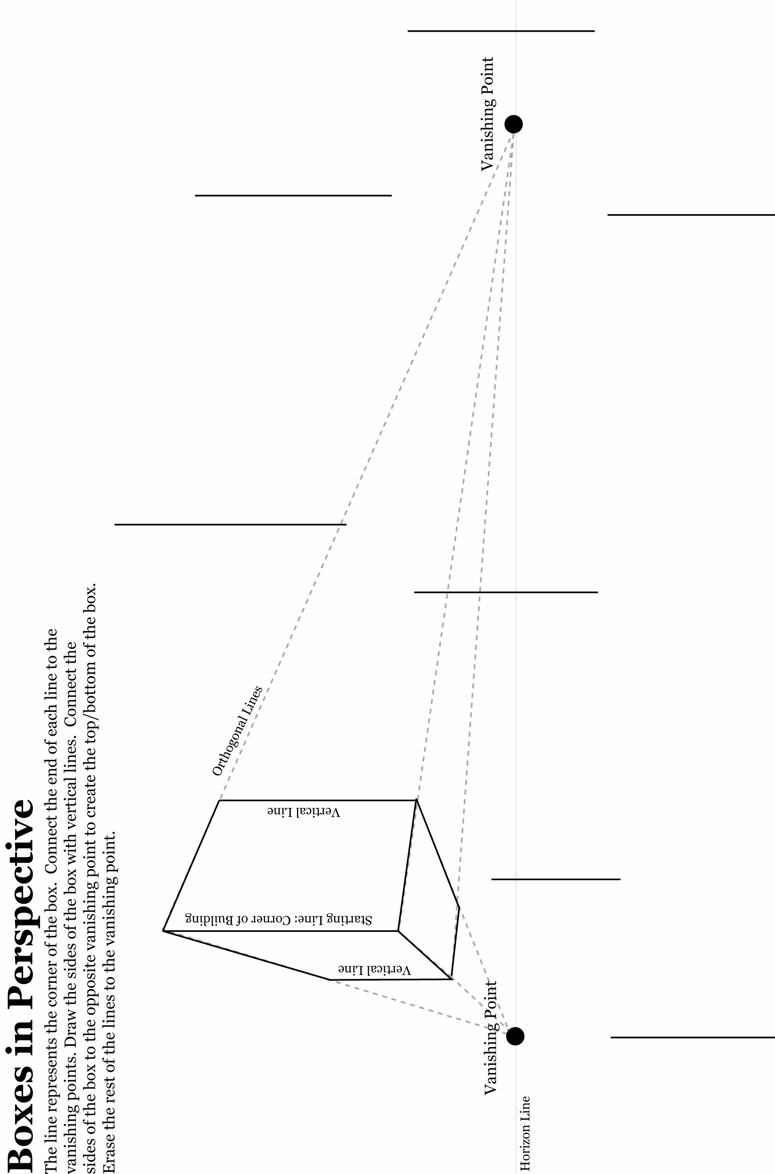
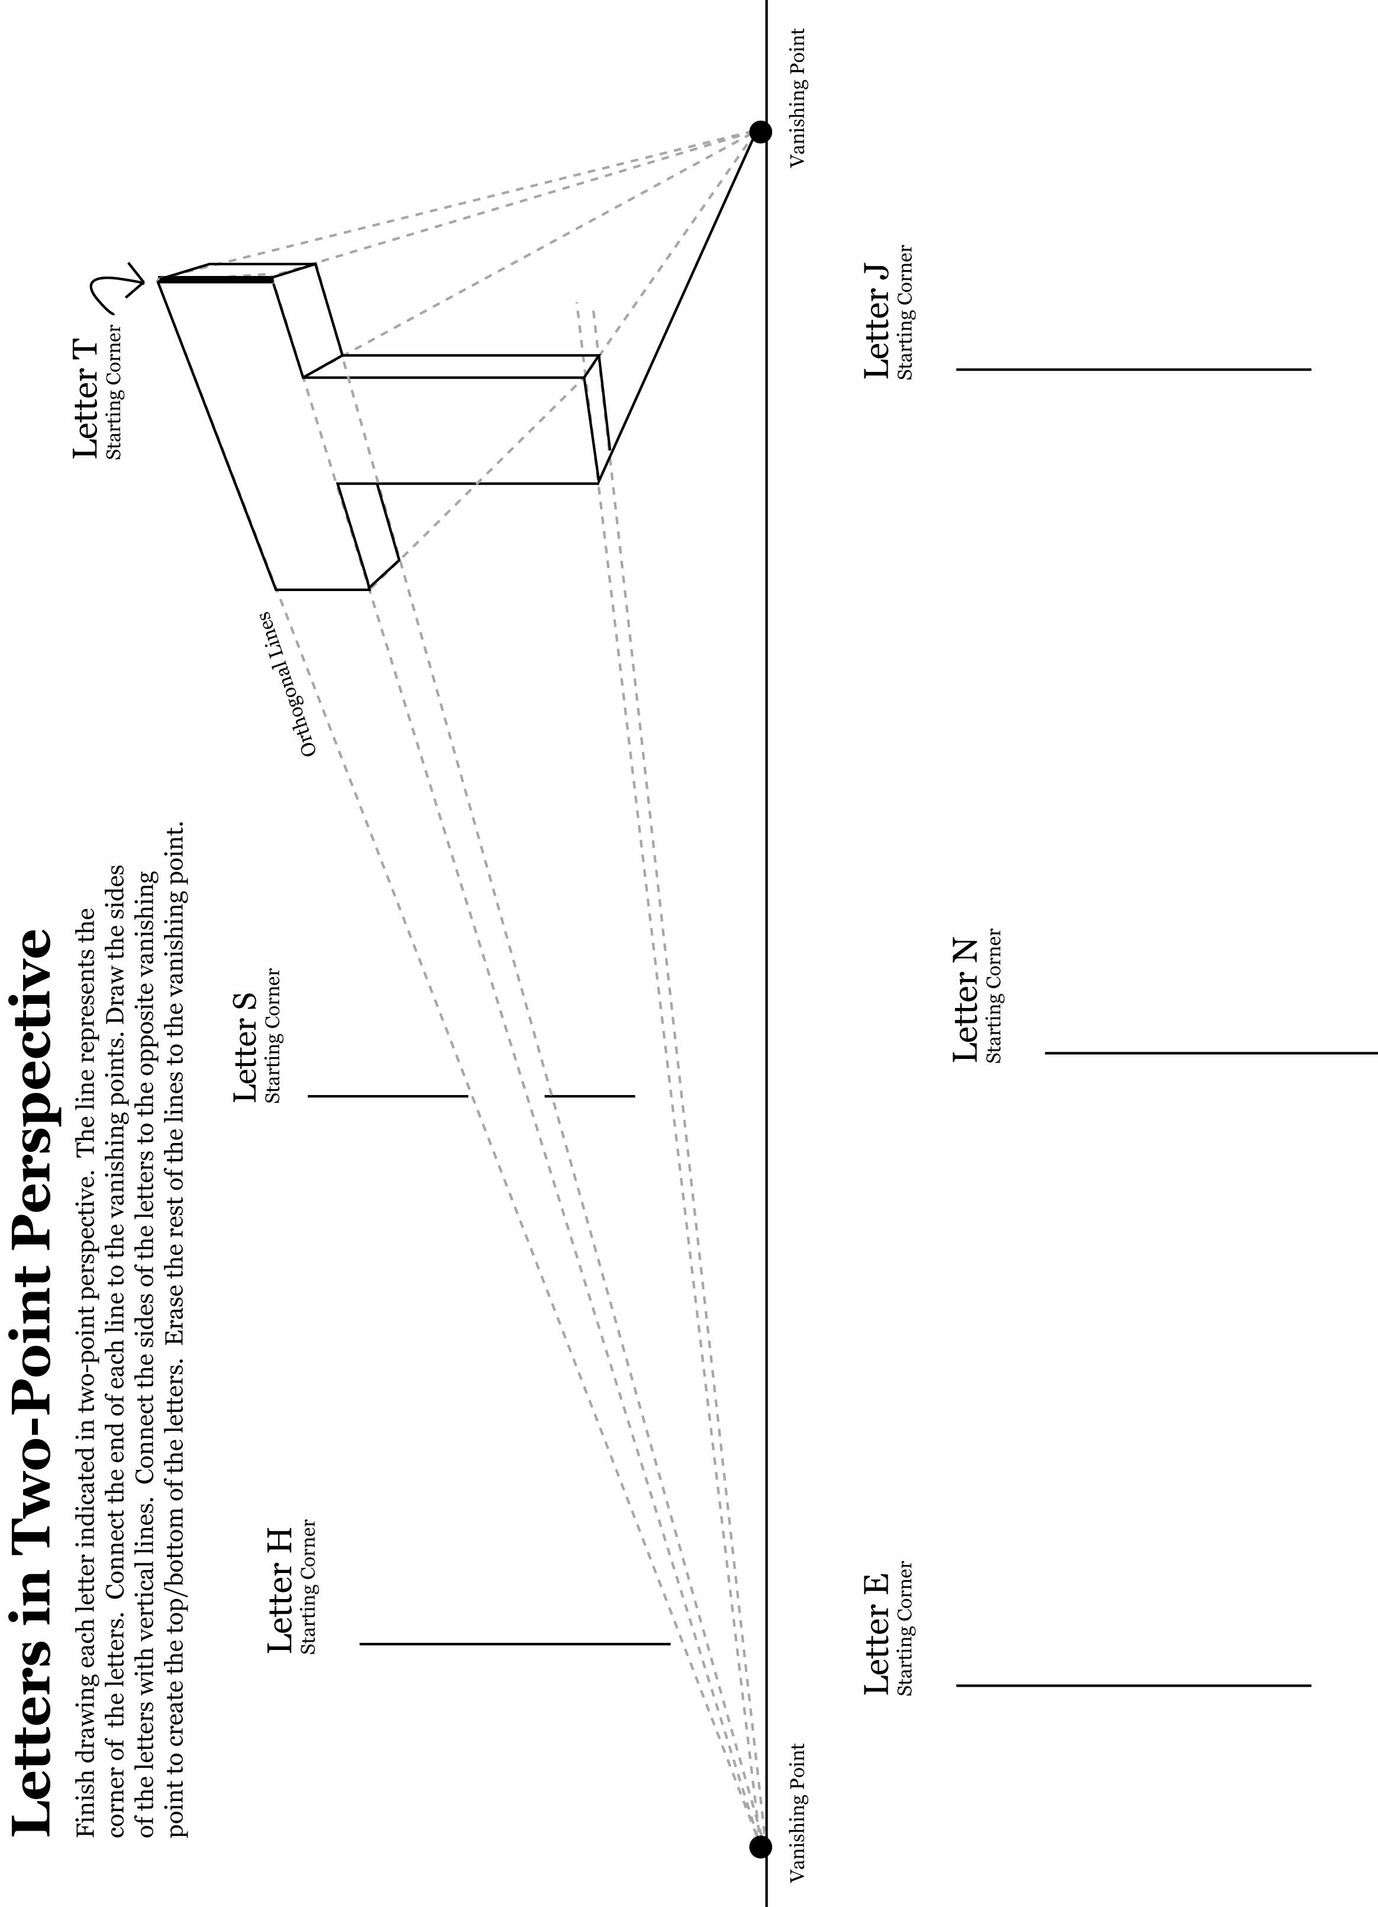
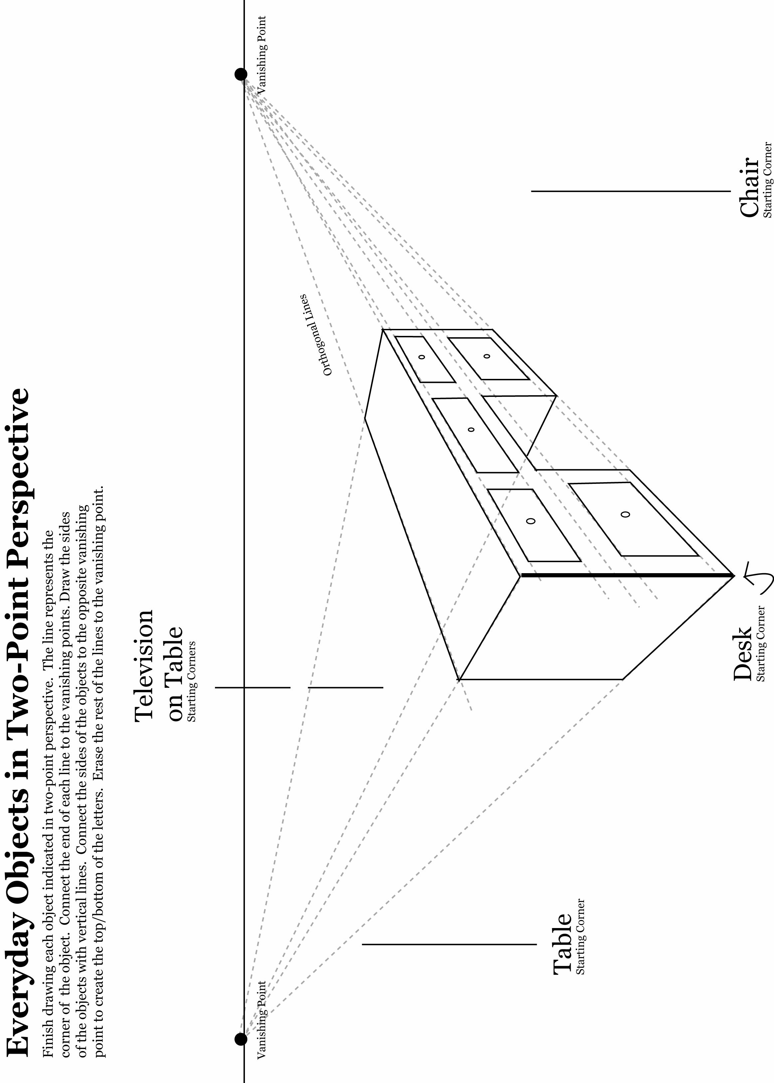
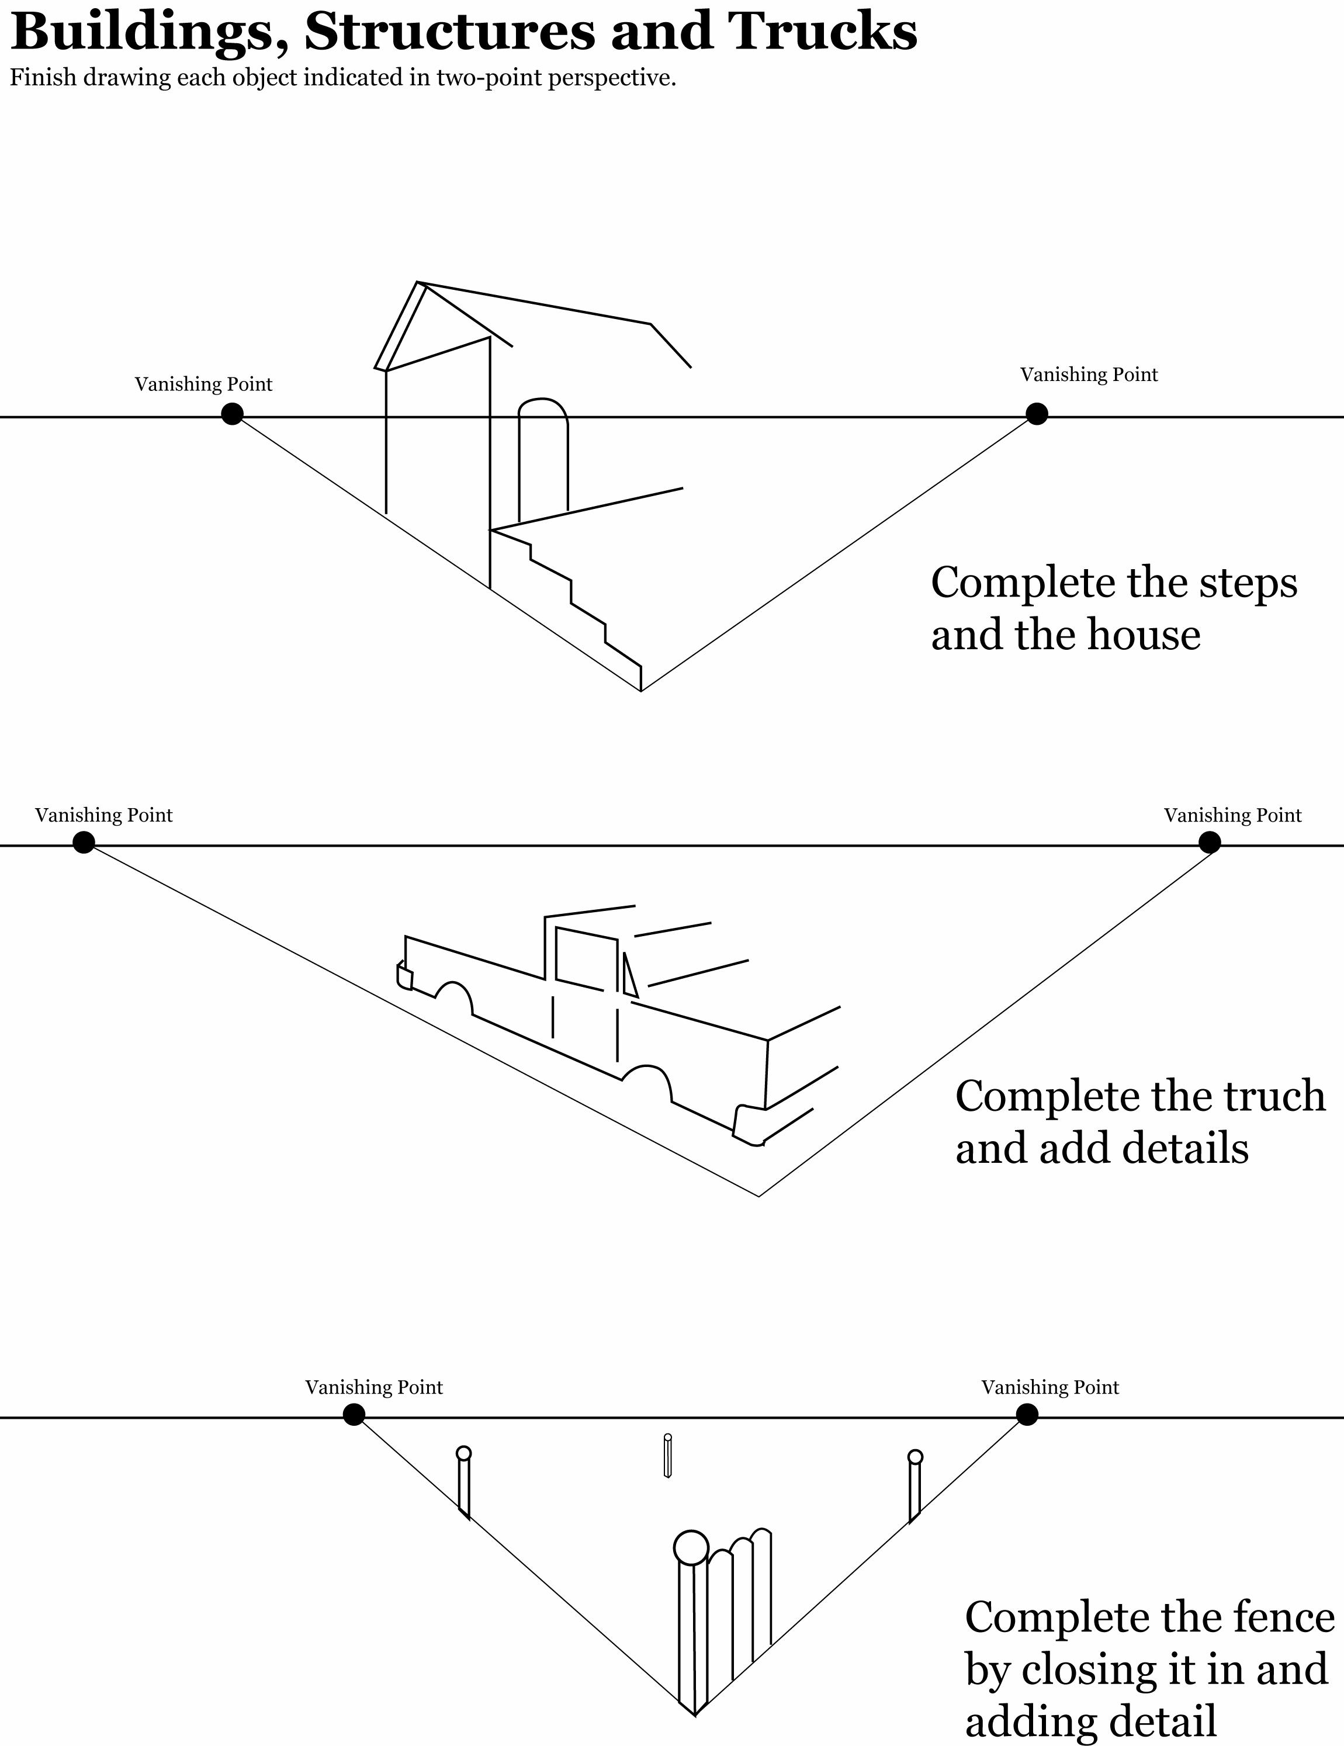
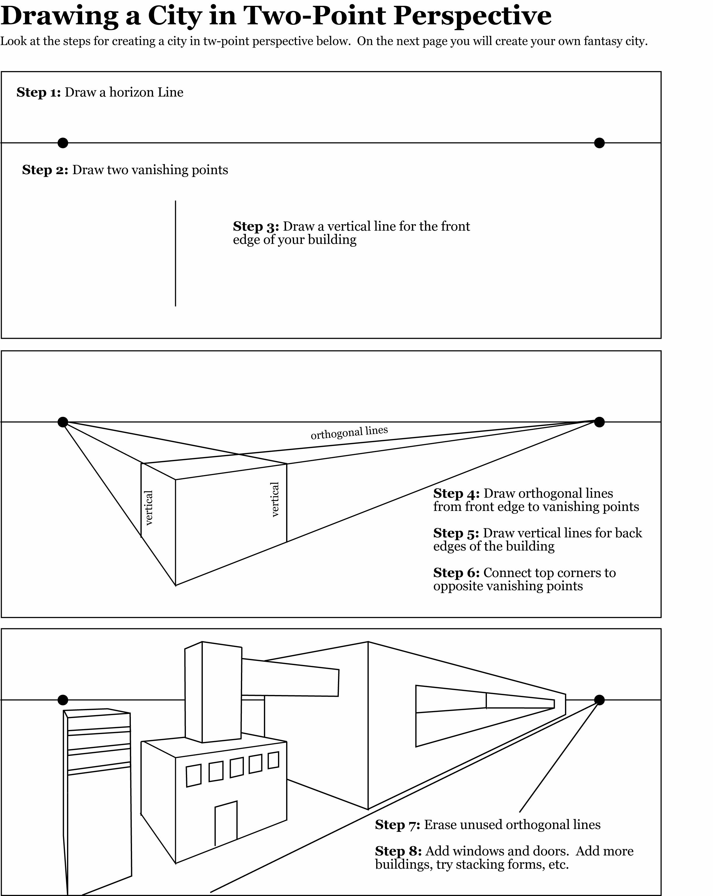
Final Project – Two Point Perspective Fantasy Building

Student Page Directions:

- You will do a rough draft before you begin to create your final drawing. Start by just drawing what your fantasy building or city would look like. Think about how it would look in two-point perspective. Indicate your horizon line and vanishing points but just sketch it out. Don’t worry about being precise on the perspective in your rough draft.

- Now it’s time to use your imagination. Think in your mind what your fantasy futuristic building might look like. Does it have hard edges, soft edges, pointy edges, funky designs, odd shapes, geometric shapes, buttons, gadgets, windows, stacked forms, elevators, landing pads, etc. Let your imagination go wild. Think of some of the cartoons and movies you have watched about futuristic times.

- Once you have completed your rough draft have the teacher sign off on it.

- Once your rough draft has been signed off on you may begin the final artwork for your “Fantasy Building.” You will start looking at where your horizon line and vanishing points are on your rough draft.

- Once you have decided where your horizon line and vanishing points are you will decide where you will start your buildings at on your page. You want to start with the building in the front of your picture and work your way to buildings in the back. Begin drawing.

- Don’t forget to add things like trees, streets, cars, signs, or anything else that will add interest to your design.

- Add a background landscape behind your horizon line. You could add a sky, sunset, mountains, storm, etc.

- Think about the other ways you show space in your drawing. Utilize some of these ways also. (size change, detail change, overlapping, vertical location, value changes, and atmospheric perspective).

- When your drawing is done show it to the teacher. She may have suggestions for improvements. When approved answer the questions on your grading rubric and turn in.

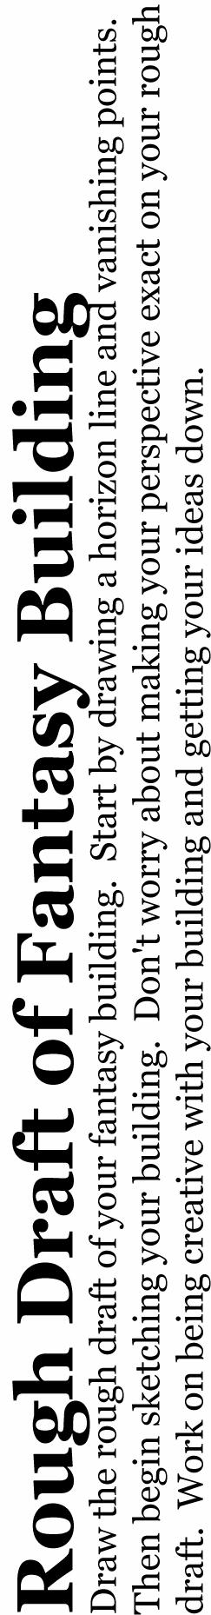
Student Name: |  | Period:
CAD 1 | 2 Point Perspective Fantasy Building | Miss Long
Category | Description | Good | Average | Needs Work
 |  | (8-10) | (5-7) | (1-4)
Follows | The student completed a rough draft and showed it to the teacher.
Directions | The student followed the directions of the project.
 | The student completed the reflection questions thoughtfully and in complete
 | sentences.
Neatness and | The student didn't rush but paid attention to consistency in work.
Craftsmanship | The sketch is neat and free from smudges, wrinkles, eraser marks, etc.
 | The design is free from mistakes that distract from the unity of the design.
Composition | The student used two-point perspective correctly. (worth 30 Points)
and Design | The student hatched their drawing.
 | The student added details that add to the interest of their drawing.
 | The student used other ways of giving the illusion of space in their drawing
 | like overlapping, detail change, value change and atmospheric perspective.
Creativity | The student was creative in designing their fantasy building.
Growth | The student shows more thought, expressiveness and skill in their drawing.
Participation | The student participated in discussions and took care of classroom materials.
Scores Subtotal
 |  | Your Total Score
 |  | Total Possible |  | 150
Reflection: (complete after your artwork is complete) |  | Grade

- How do you think your final drawing turned out? Do you like it or not like it and why?

- If you could change anything about your design what would it be?

3. Describe what you have learned about space and perspective.

