One Point Perspective

Investigate
What is “One Point Perspective”?
One point perspective is a very simple and easy way to draw three-dimensional drawings. One point perspective has also been called central perspective and single-point perspective. These names obviously describe a situation where only one direction point is needed to draw an entire form or scene. This point itself is at times called the central vanishing point, principal vanishing point or center of vision. This kind of drawing will create deepness to the drawing, because it seemed to us that the vanishing point is very far away, while actually it is just that every shape is going into one direction.
Why is “One Point Perspective” a good technique?
It can help our drawings look more realistic and professional. If we are viewing an object from above, its bottom must look smaller than it’s top, and plotting a vanishing point will make all the objects in our drawings have accurate scale.
How do we actually draw a One Point Perspective?
In order to draw a One Point Perspective we have to plot a vanishing point. Vanishing points are found everywhere in real life: at the end of train trails, hallways, roads, etc; so it would be very easy to plot one point as soon as you got an idea of what you are drawing. Next, draw two oblique lines coming from the point; make sure these two lines form a shape: roads, train tracks, pencil, etc. Then, draw vertical lines everywhere in your drawing, and make sure all of them are going right straight into your vanishing point, you will be able decide the sizes of the spaces between each line; just notice that the smaller they are, the more detailed picture you can draw. Then, draw horizontal lines all over your drawing. After that, draw every shape you want, based on those boxes you have in your drawing. Soon, you will realize each of the shapes seemed to be going into that vanishing point.

Search the Internet for these answers:

- What is one point perspective?
- How do I draw a one point perspective?

Design
It is time to start brainstorming designs. First, what are some things you can think of that are good examples of one point perspective? List at least five:
1.
2.
3.
4.
5.

Now it’s time to sketch. Here is an example of what you are to sketch using your ideas:

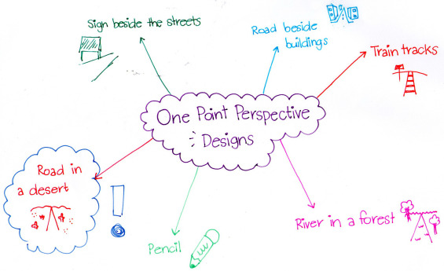

Plan your drawing
After you’re finished with brainstorming, you will start a practice drawing. Practices can be relatively messy, so no worries…neatness will come in the final drawing. Lay out your horizon, and determine your vanishing point. Sketch your design.

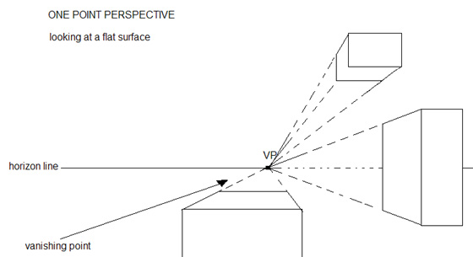
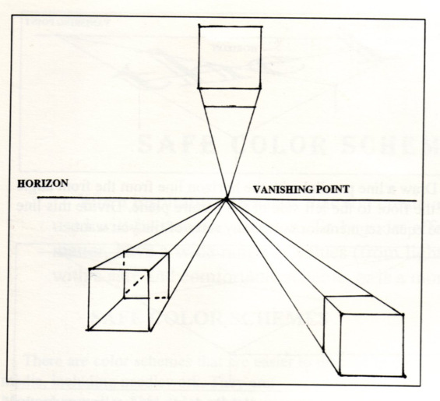

Draw in AutoCAD
After you’re finished with everything above, it’s time to put your drawing in AutoCAD. This is due FRIDAY.

