Parts of a Dimension QUIZ
Each question is worth 10 points
2.__________________
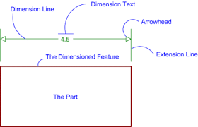

The Object
3.__________________
4.__________________
1.__________________
5. What is the most important rule of dimensioning? _____________________________________________________________________________________
6. What is linear dimensioning? _____________________________________________________________________________________
7. TRUE or FALSE It is important to dimension an object in each view to insure proper dimensioning.
8. TRUE or FALSE The more dimensions you add to a drawing the better.
9. What is the unit of measurement we use in America? _______________________________________
10. Draw the diameter symbol: _______________

NAME: _________________________
PERIOD: ________________________

